Project Report

On

“Introduction to Virtualization with VirtualBox in linux”

MASTERS OF COMPUTER APPLICATIONS



Submitted By: Project Guide:

Ansin Madhav S J Er. Prabhjot Kaur

(24MCA20193) MCA Dept., (CU)

DEPARTMENT OF COMPUTER APPLICATION,

CHANDIGARH UNIVERSITY,

(NH05, Chandigarh-Ludhiana Highway , Gharuan, Mohali , Punjab , India)

SESSION 2024-26

# DECLARATION

# 

I, Ansin Madhav , hereby declare that this project report titled *"*Introduction to Virtualization with VirtualBox in linux *"* is original work carried out by me under the supervision of Er. Prabhjot Kaur. I further declare that this work has not been submitted to any other institute/university for the award of the degree of Master of Computer Applications.

StudentName: **Ansin madhav**

Roll No: **24MCA20193**

# ACKNOWLEDGEMENT

I express my sincere gratitude to my project guide, Er. Prabhjot Kaur, for invaluable guidance and support throughout this project. I also extend my thanks to Chandigarh University for the opportunity to undertake this project and to my classmates and family for their continuous encouragement.

**Ansin madhav**

24MCA20193



TABLE OF CONTENTS

9

. Reference

. Conclusion

8

1

. Introduction

2

. System Requirement

6

. Install Ubuntu on the Virtual Machine

7

. Post-Installation Configuration (Optional

)

-

5

. Create a New Virtual Machine in VirtualBox for Ubuntu

10

11

1-2

2-4

6-9

5-6

1.1-

Background

Objective

1.2-

Guest Operating System

2.2-

Requirements

Additional Software Requirements

2.3-

Install VirtualBox Guest Additions

7.1

Test VM Features

7.2-

5.1-

Open VirtualBox and Create a VM

Allocate RAM for the VM

5.2-

Create a Virtual Hard Disk

5.3-

6.1-

Select the Ubuntu ISO File

6.2-

Begin Ubuntu Installation

6.3-

Select Keyboard Layout

6.4-

Choose Installation Type

6.5-

Set Time Zone and User Credentials

6.6-

Complete the Installation

6.7-

Remove the ISO and Reboot

1

4

Host System Requirements

2.1-

10

Download Ubuntu ISO File

4

. Download and Install VirtualBox on Windows

3

4.1- -

Download Ubuntu

3.1-

Download VirtualBox

Install VirtualBox

3.2-

Launch VirtualBox

3.3-

Introduction

Virtualization is a powerful technology that allows multiple operating systems to operate concurrently on a single physical machine. By abstracting the underlying hardware, virtualization provides an environment where applications can run independently, enhancing flexibility and resource utilization. VirtualBox, developed by Oracle, is a widely-used open-source virtualization platform that facilitates the creation and management of virtual machines (VMs) on various operating systems, including Windows. This project, "Introduction to Virtualization with VirtualBox on Windows," aims to provide users with a comprehensive understanding of how to install VirtualBox, create and configure VMs, and utilize virtualization for testing, development, and deployment purposes.

The project will guide users through the process of setting up VirtualBox on a Windows host system and installing a Linux guest operating system, such as Ubuntu. By leveraging VirtualBox, users can create isolated environments that allow for experimentation, testing of different software configurations, and running applications without the risk of affecting the host system. Virtualization also enables developers to replicate production environments, streamline application testing, and optimize hardware resources.

This project emphasizes the significance of virtualization in contemporary computing, highlighting its applications in software development, IT management, and cloud computing. By mastering VirtualBox on Windows, users can enhance their technical skills and adapt to the evolving demands of the technology landscape.

1.1. Objective

The objective of this project is to explore virtualization technology using VirtualBox on a Windows operating system. Virtualization enables the creation of multiple virtual environments on a single physical machine, allowing for better resource utilization and management. This report covers the installation and configuration of VirtualBox in Windows, the creation and management of virtual machines, and an overview of the use cases for virtualization.

1.2. Background

Virtualization is a key technology in modern computing, enabling the abstraction of hardware resources to create isolated environments. It is commonly used in server consolidation, testing environments, and resource management in cloud computing.

VirtualBox is a powerful open-source hypervisor for x86 virtualization. It is widely used due to its ease of use, flexibility, and support for a wide range of guest operating systems, including Linux, Windows, and macOS.

# System Requirements

Before installing VirtualBox and creating virtual machines on a Windows system, ensure that your hardware and software meet the following minimum requirements:

## 2.1 Host System Requirements

RAM : Minimum of 4 GB (8 GB or more recommended for better performance).

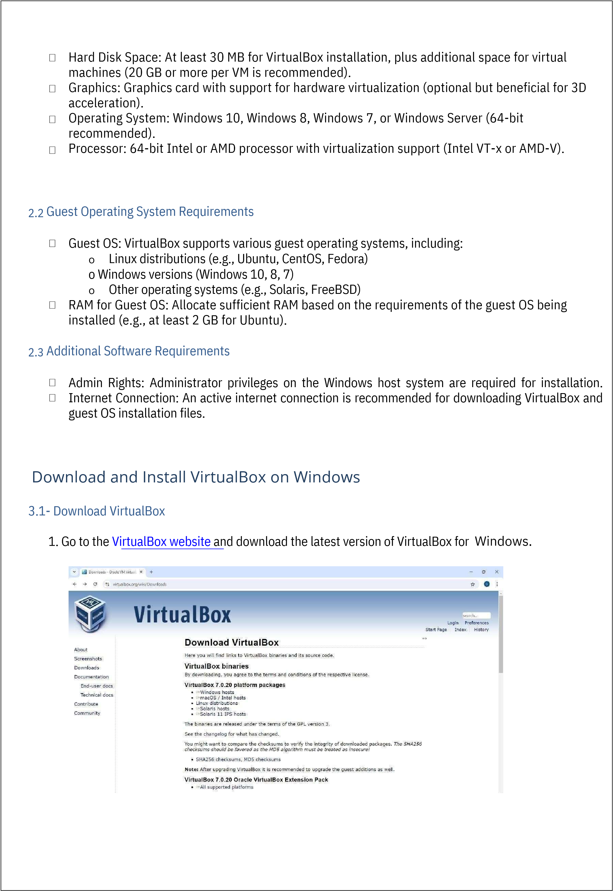

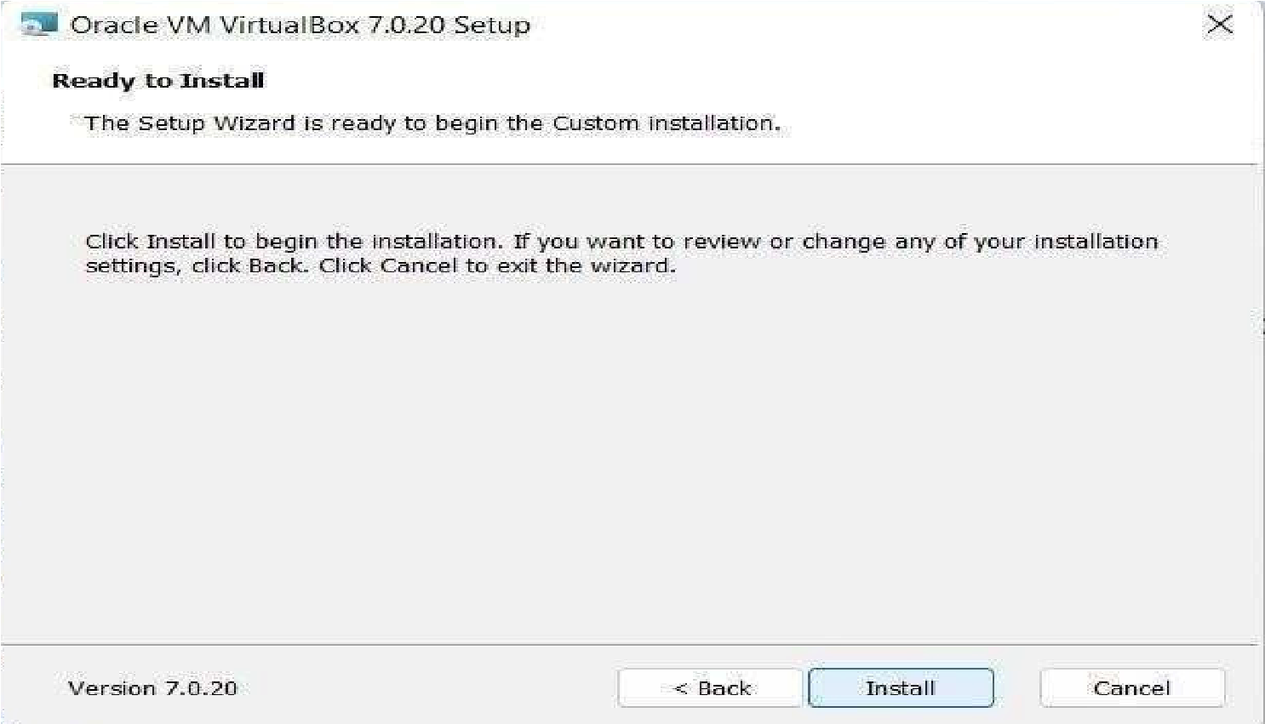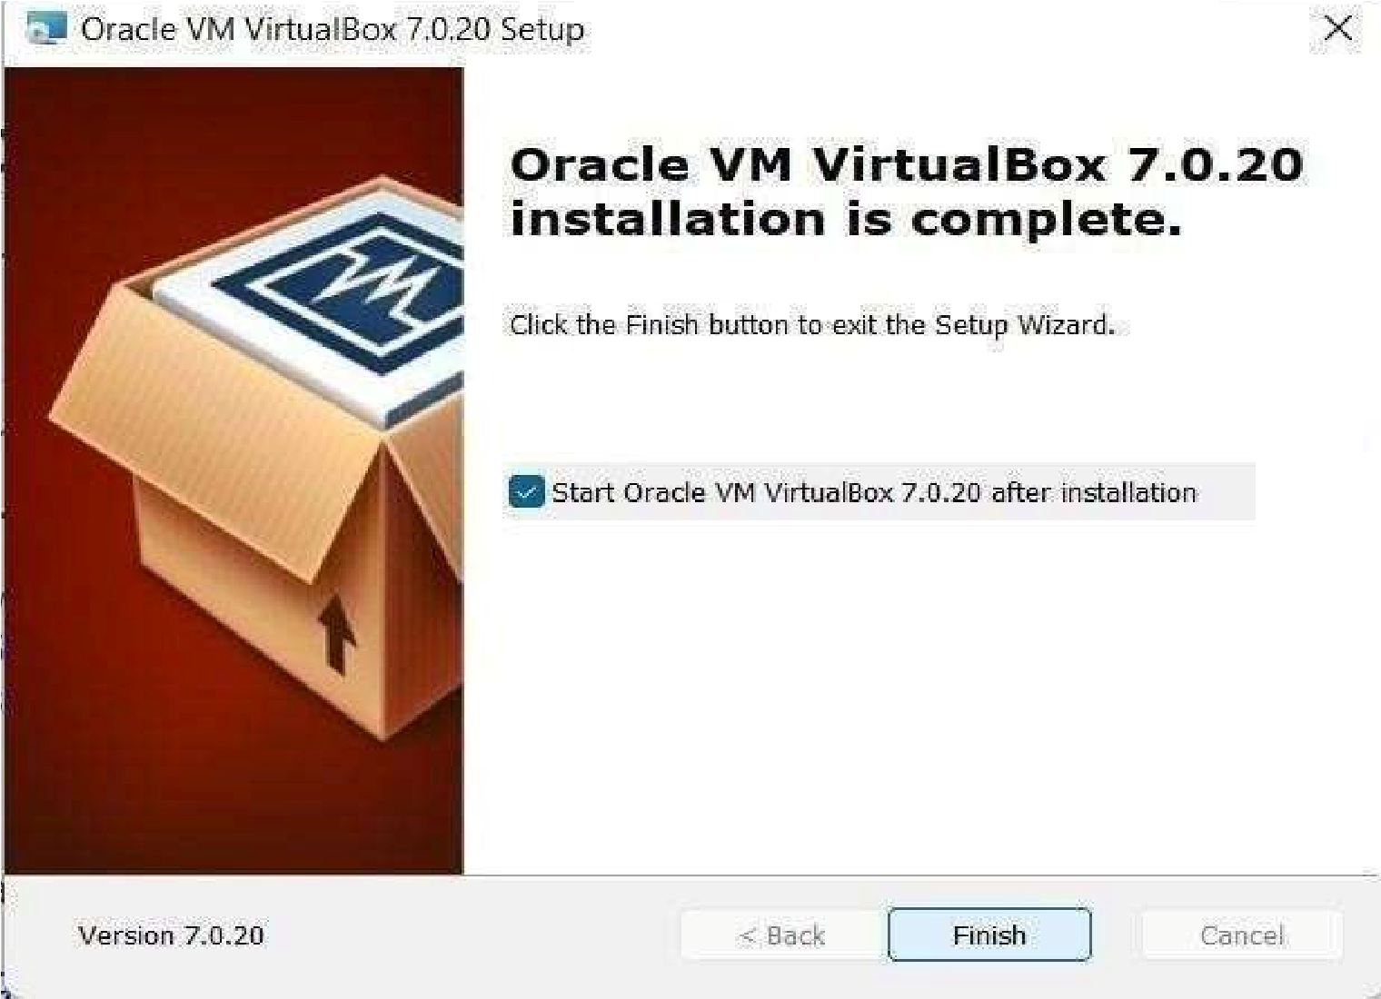

Run the installer you just downloaded (VirtualBox-x.x.x-xxxx-Win.exe).

In the installation wizard, click Next on the welcome screen.

Select the installation location (default is fine), and click Next.

The next screen will show some options for creating shortcuts.

You can leave them as default.

Click Yes to install network interfaces (this is required for VirtualBox networking).

Click Install and wait for the installation to complete.

3.2-

Install VirtualBox

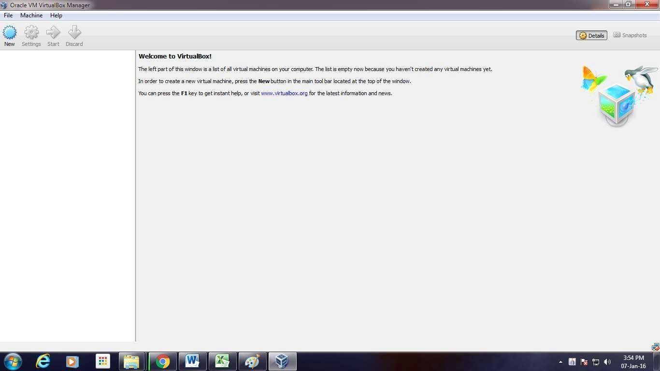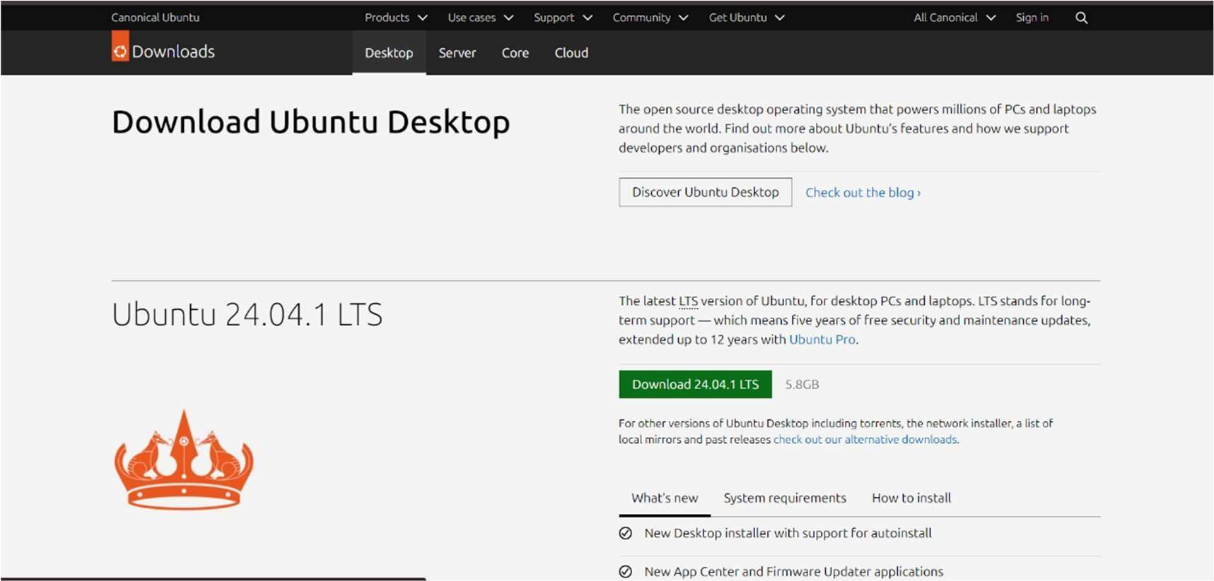

1

. Visit the

Ubuntu Downloads page

and download the latest version of Ubuntu (e.g.,

LTS).

After the installation, VirtualBox will automatically launch. You’ll see the main VirtualBox interface.

4.1-

Download Ubuntu

3.3-

Launch VirtualBox

Download Ubuntu ISO File

Ubuntu 22.04

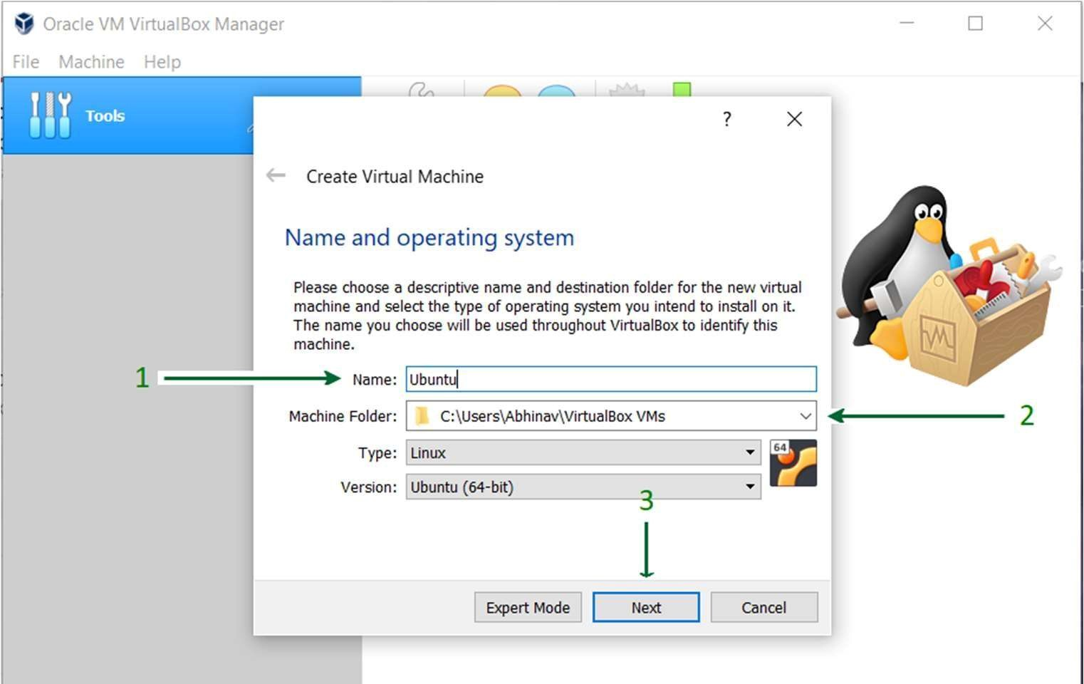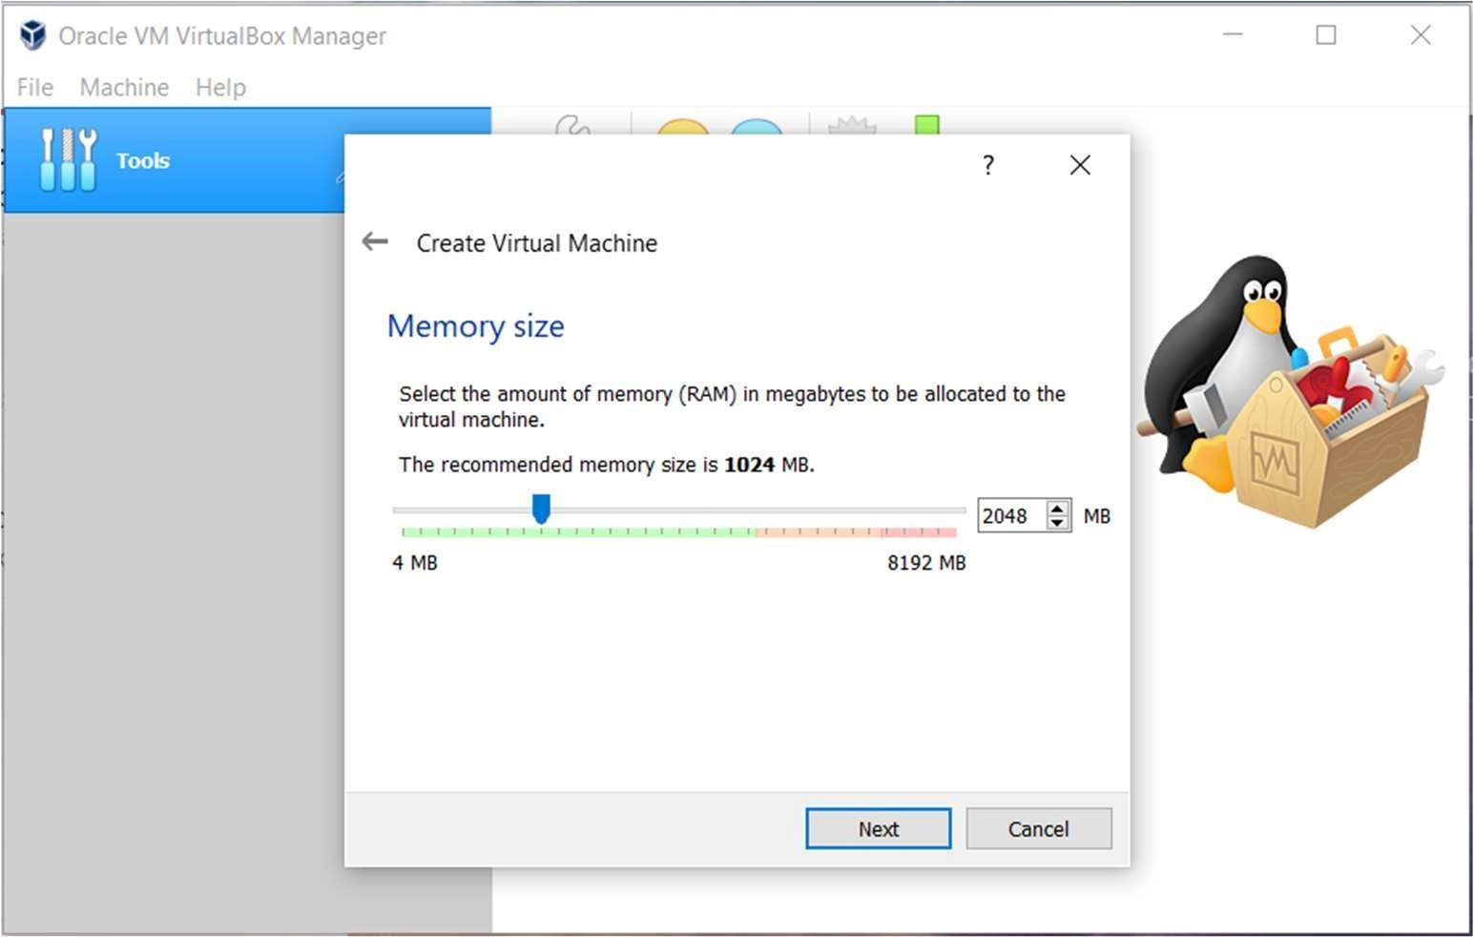

VirtualBox will ask you to allocate memory (RAM). Set at least

depending on your system’s capabilities.

Click Next.

In VirtualBox, click the New button to create a new virtual machine.

In the Name field, enter "Ubuntu VM" or any name of your choice.

Under Type, select Linux, and under Version,

select Click Next.

.

or more,

Create a New Virtual Machine in VirtualBox for Ubuntu

5.2-

Allocate RAM for the VM

5.1-

Open VirtualBox and Create a VM

1.

2.

Ubuntu (64-bit)

2048

MB (2 GB

)

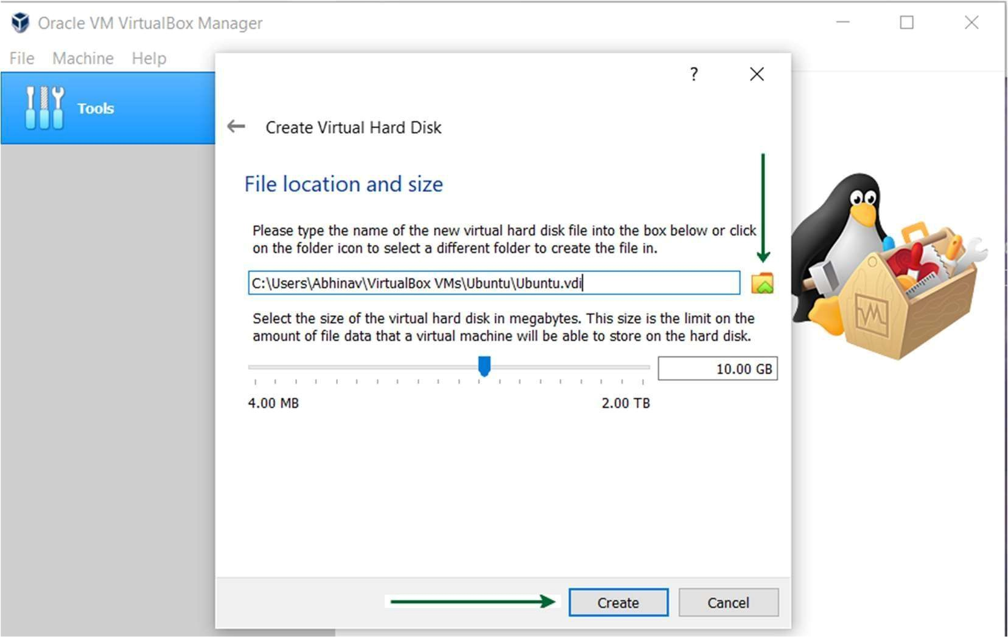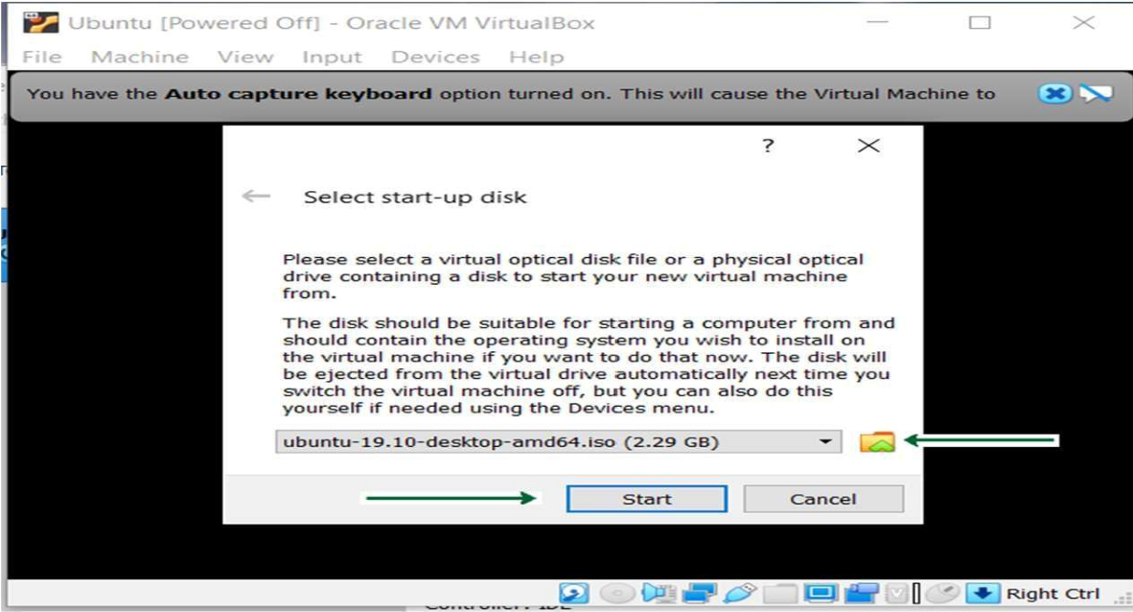

Choose

Select the

Select

Set the disk size to at least

In VirtualBox, select your newly created VM and click

A window will appear asking you to select a

for the Ubuntu ISO file you downloaded earlier.

Select the ISO and click Start.

and click Create.

format and click Next.

(

this saves disk space

).

or more if you want), and click

(

.

. Click on the folder icon and browse

6.1-

Select the Ubuntu ISO File

5.3-

Create a Virtual Hard Disk

1.

2.

3.

4.

1.

2.

3.

Create a virtual hard disk now

VDI (VirtualBox Disk Image)

Dynamically allocated

20

GB

Start

start-up disk

Create.

Install Ubuntu on the Virtual Machine

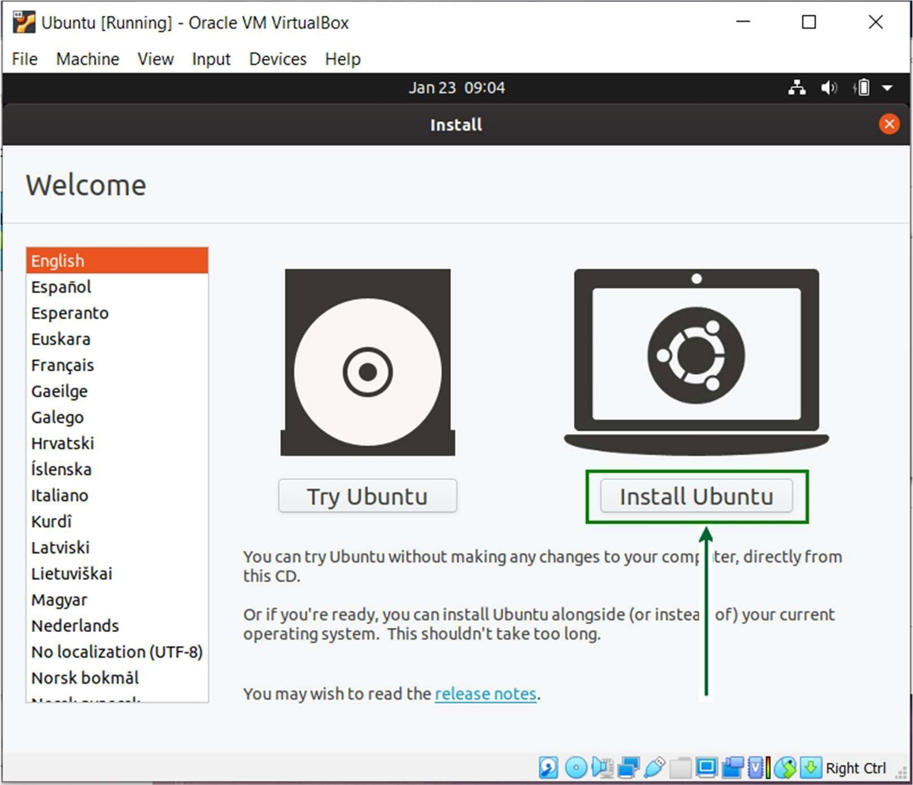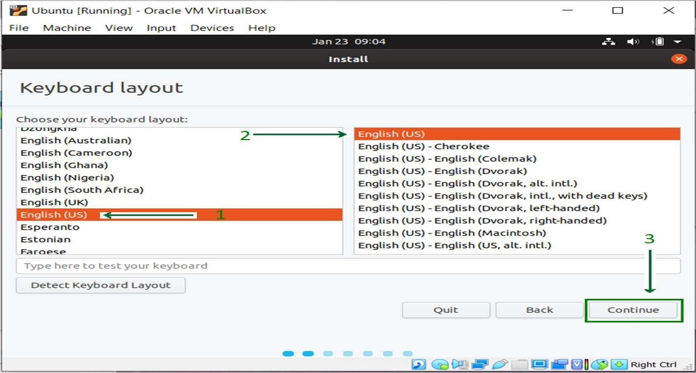

1

. Choose your

(

default is usually fine) and click

After starting, the VM will boot from the Ubuntu ISO, and you’ll see the

Click Install Ubuntu.

6.3-

Select Keyboard Layout

6.2-

Begin Ubuntu Installation

1.

2.

keyboard layout

Continue.

Ubuntu installer.

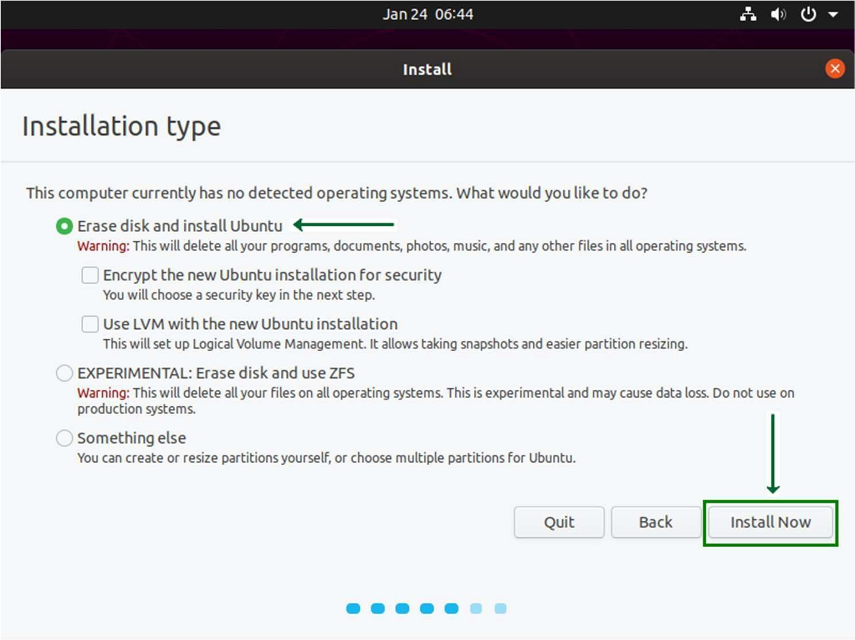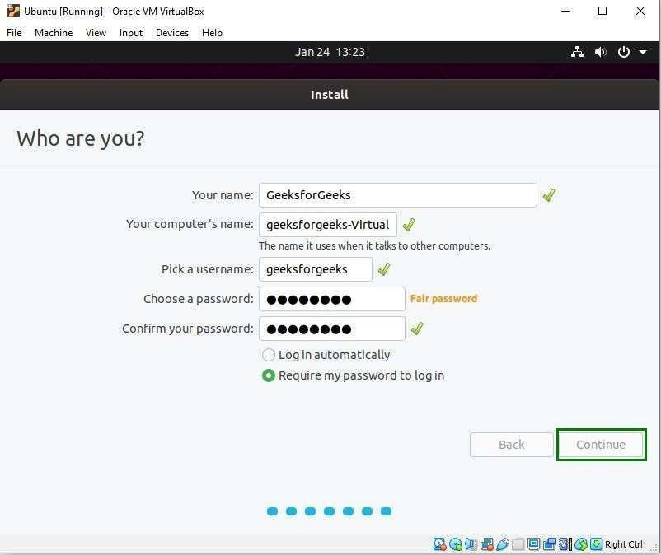

Select your

Enter your

Click

, and

In Updates and Other Software, choose the option to install

In the Installation type screen, select

machine, it won’t affect your host system).

Click Install Now.

(

).

optional

(

since this is a virtual

6.4-

Choose Installation Type

Set Time Zone and User Credentials

6.5-

1.

2.

3.

1.

2.

3.

time zone.

name, computer name, username

Continue.

password.

third-party software

Erase disk and install Ubuntu

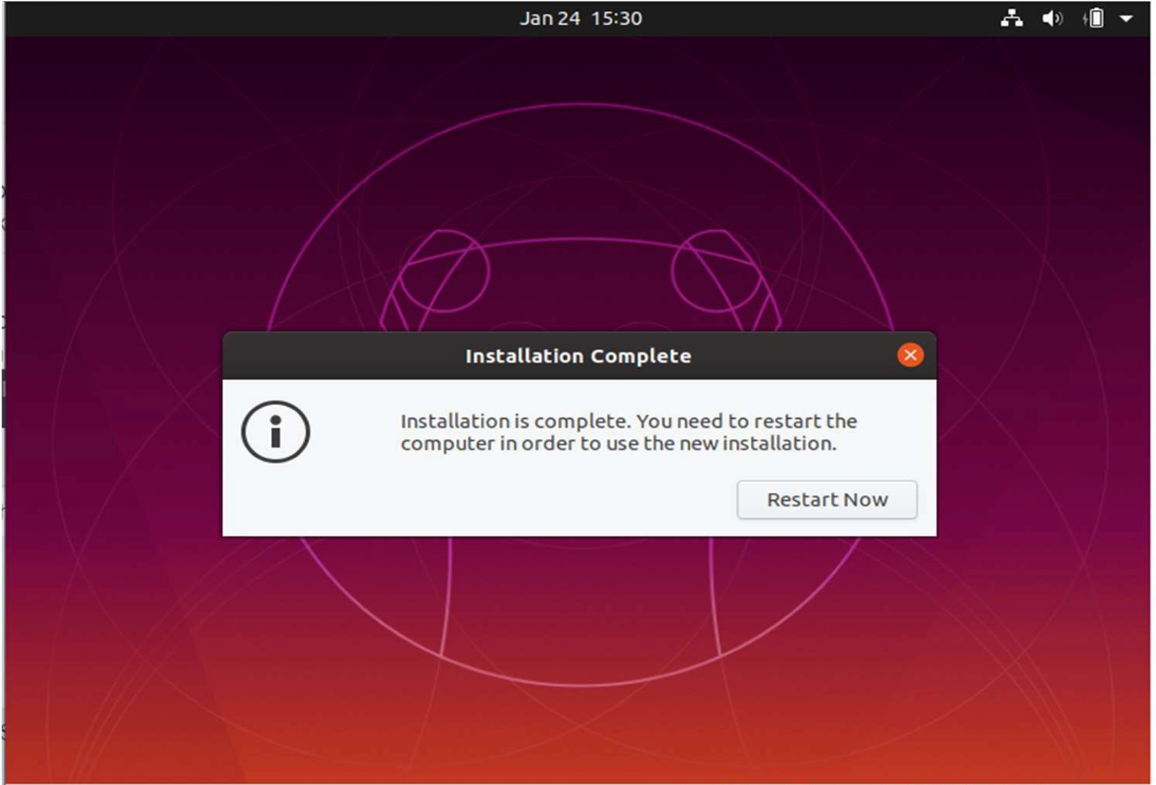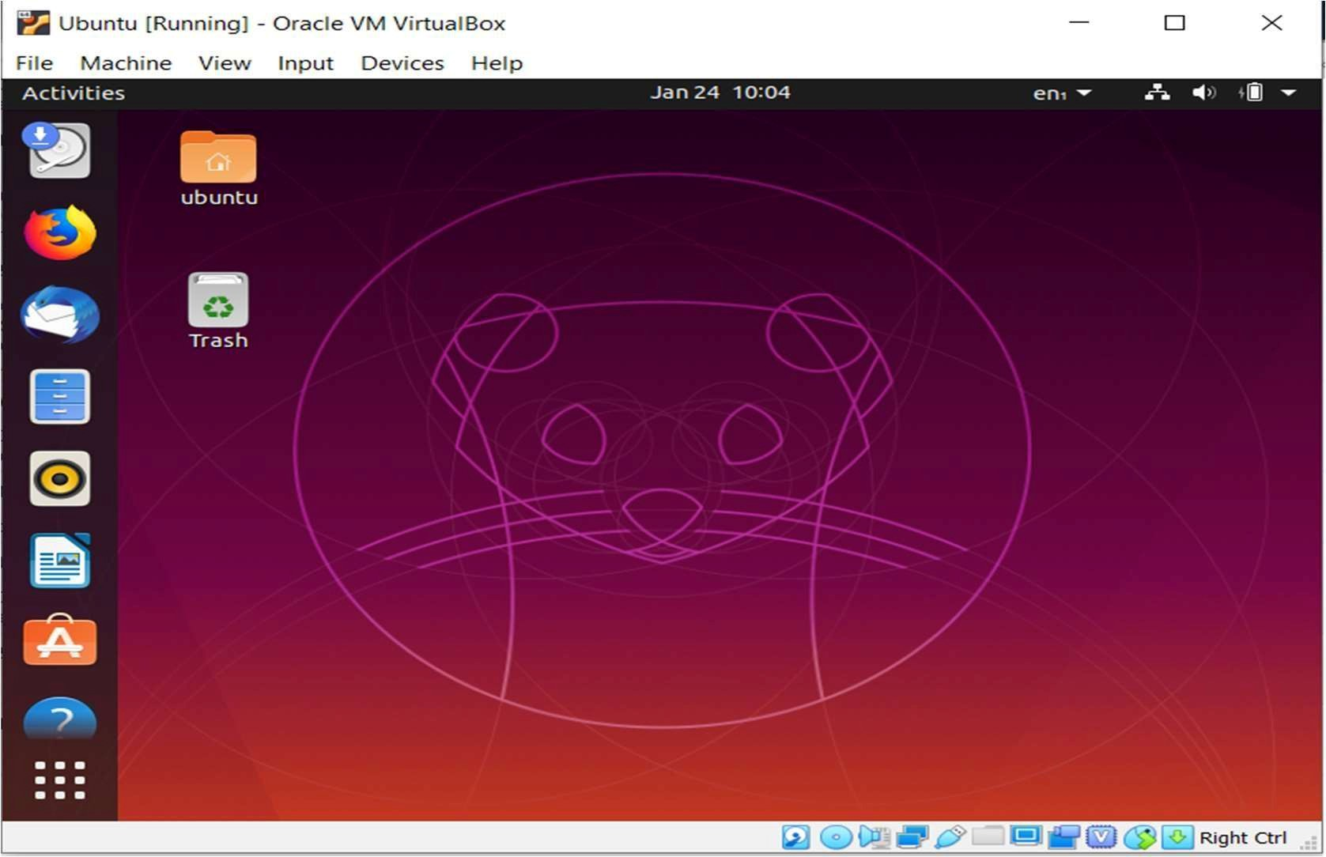

Before rebooting, go to the

disk from virtual drive.

Reboot the VM by clicking

menu in VirtualBox, then

.

Ubuntu will start installing. This process may take a few minutes.

Once the installation is done, click Restart Now.

, and select

6.6-

Complete the Installation

6.7-

Remove the ISO and Reboot

1.

2.

1.

2.

Devices

Restart Now

Optical Drives

Remove

# Post-Installation Configuration (Optional)

## 7.1- Install VirtualBox Guest Additions

VirtualBox Guest Additions improves performance and allows features like auto-resizing of windows and clipboard sharing between the host and guest OS.

1. In the Ubuntu VM, click Devices -> Insert Guest Additions CD Image.
2. Ubuntu will detect the CD and ask you to install the software. Follow the prompts to install Guest Additions.
3. After the installation is complete, restart your VM.

## 7.2- Test VM Features

1. Resize the VM window to see if auto-resizing works.
2. Test clipboard sharing between your Windows host and Ubuntu guest.

# Conclusion

The project "Introduction to Virtualization with VirtualBox in Linux" has provided a comprehensive exploration of virtualization technology and its practical applications in modern computing environments. By utilizing VirtualBox as a powerful open-source virtualization platform, users can create and manage multiple virtual machines, facilitating the simultaneous operation of various operating systems on a single physical host.

Throughout the project, we have demonstrated the process of installing VirtualBox on a Linux host system, setting up a Linux-based guest operating system, and configuring essential features for optimal performance. This hands-on experience has illustrated the numerous benefits of virtualization, including improved resource allocation, enhanced security through isolation, and the ability to rapidly deploy and test applications in a controlled environment.

The significance of virtualization in software development, IT management, and cloud computing cannot be overstated. It allows developers and system administrators to replicate production environments, conduct thorough testing, and streamline workflows without the need for extensive physical hardware. By leveraging VirtualBox, users can effectively simulate diverse scenarios, making it an invaluable tool for learning and experimentation.

In conclusion, mastering virtualization with VirtualBox in Linux equips users with essential skills for navigating today’s technology-driven landscape. The ability to create isolated virtual environments fosters innovation, reduces costs, and enhances overall operational efficiency. As the demand for virtualization continues to grow, understanding and implementing these concepts will be crucial for both aspiring and experienced IT professionals. This project serves as a foundational step toward harnessing the full potential of virtualization technology in various domains.



References

1.

2.

3.

4.

5.

6.

Virtualization Basics

o

Linux Documentation

o

DigitalOcean Tutorials

o

Ubuntu Installation Guide

o

VirtualBox Installation Guide

o

Oracle VirtualBox Documentation

o

Oracle.

).

n.d.

(

https://www.virtualbox.org/manual/

Ubuntu.

(

n.d.

).

Ubuntu

Desktop

https://ubuntu.com/tutorials/install-ubuntu-desktop

The

Linux

Documentation

Project.

).

n.d.

(

http://www.tldp.org/HOWTO/Virtualization-HOWTO.html

VMware.

).

(

n.d.

What

is Virtualization?

https://www.vmware.com/topics/glossary/content/virtualization

Retrieved

Retrieved

Retrieved

Retrieved

How-To Geek. (2021). How to Install VirtualBox on Windows 10. Retrieved from

https://www.howtogeek.com/667867/how-to-install-virtualbox-on-windows-10/

from

from

from

from

DigitalOcean. (2020). How To Install and Configure VirtualBox on Ubuntu 20.04. Retrieved

from

https://www.digitalocean.com/community/tutorials/how-to-install-and-

configure-

virtualbox-on-ubuntu-20-04

VirtualBox

Installation

Documentation.

Guide.

Virtualization.